*** Disclaimer- This information was gathered to assist you. It is not an endorsement for any of the locations or eateries. Prices in lodging pictures are not current.
Mt. Airy, GA – Camp Hawkins -
Run by Caleb and Rachel Laubrich (A MFT student)
Rachel’s number is 678-877-7139. She and her husband run a summer camp for kids with special needs. Therefore, their entire camp is handicapped accessible for anyone who needs it! The address is 800 Rudeseal Rd. Mt. Airy GA. It is about 15 minutes away from TFC. Students who need lodging for residency always have a free place to stay here if they want!

Toccoa, GA

Unfortunately, the town of Toccoa does NOT have any recommendable hotels in which to stay.

Examples of places to eat in Toccoa, Georgia:
Fast food: Chick-fil-a, Burger King, Bojangles, Taco Bell, KFC, Hardee’s, Dairy Queen, Brother John Subs, Zaxby’s, Firehouse Subs
Local: Bell’s Drive-in, M & J’s Home Cooking (buffet), Puerto Nuevo, Juniors Steakhouse, Bar-b-que Shack.

DO NOT book with (QUALITY INN/MY Home and Suites) or REGENCY INN if they come up when you google them.
The hotel that may come up under Quality Inn is no longer a Quality Inn, and a student did not have a good experience.
Regency Inn has had issues with law enforcement having to be called.

Lavonia, GA
Places in Lavonia, GA. Distance from college is approximately 20 miles.
Examples of place to eat in Lavonia: Lavonia Exit and downtown options:
Fast food: Dairy Queen, Zaxby’s, Burger King, Chick-fil-a, Subway, McDonald’s, Whataburger
Local: Southern Appalachian Smokehouse, Bella Bella Mozzarella, Finley’s Café, 211 Main Street Bakery and Restaurant
Chain: Longhorns Steakhouse, Cracker Barrell, Pizza Hut, and J Peters Grill

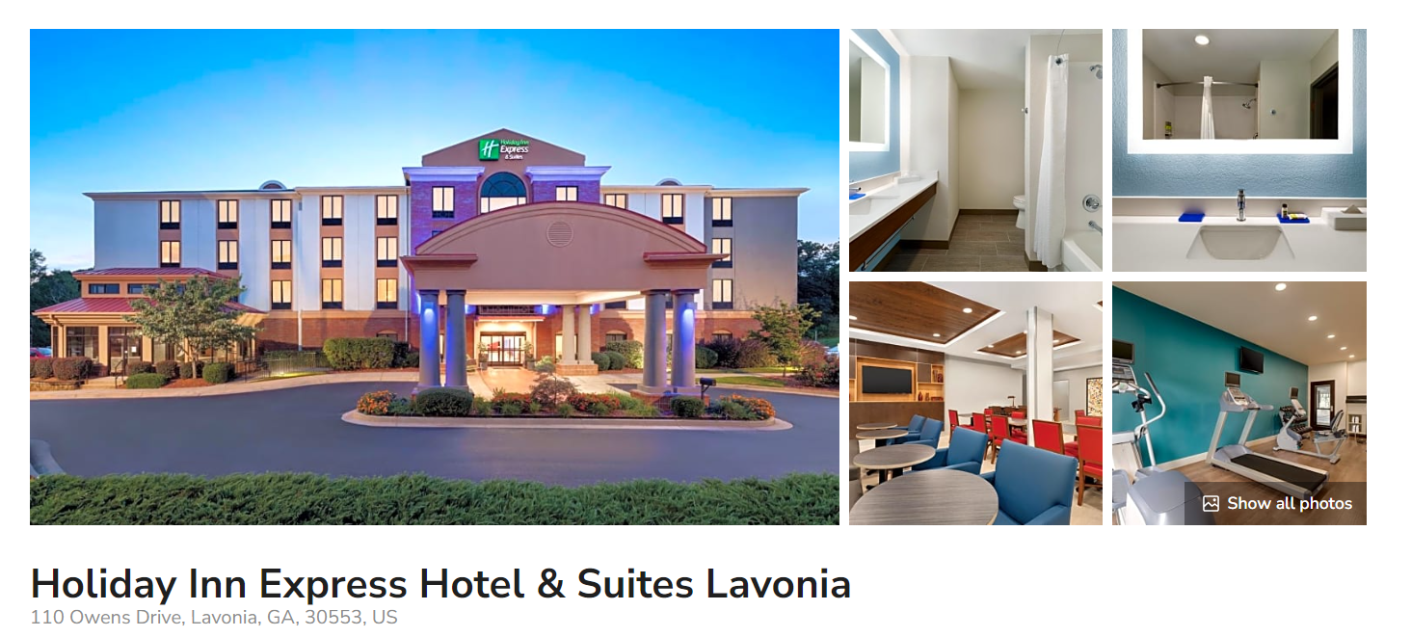
Click here for link to Holiday Inn Express in Lavonia, GA website.

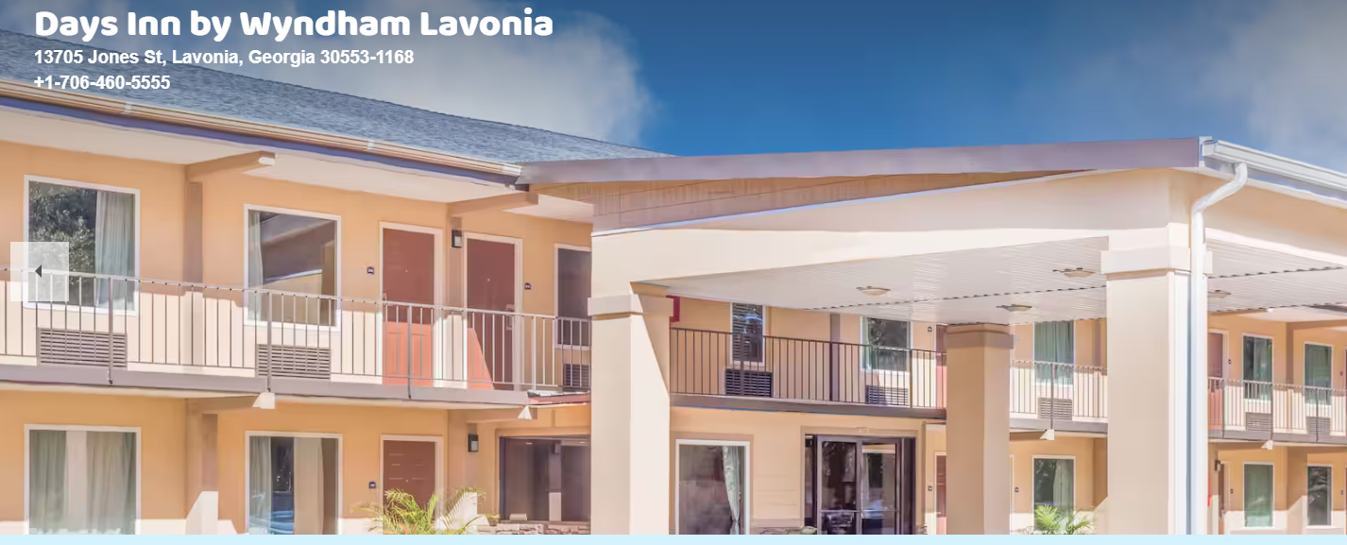
Click here for link to Days Inn by Wyndham in Lavonia, GA website.

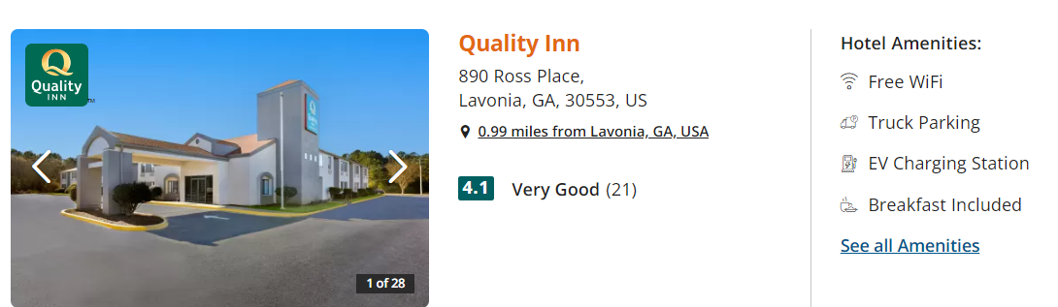
Click here for link to Quality Inn in Lavonia, GA website.

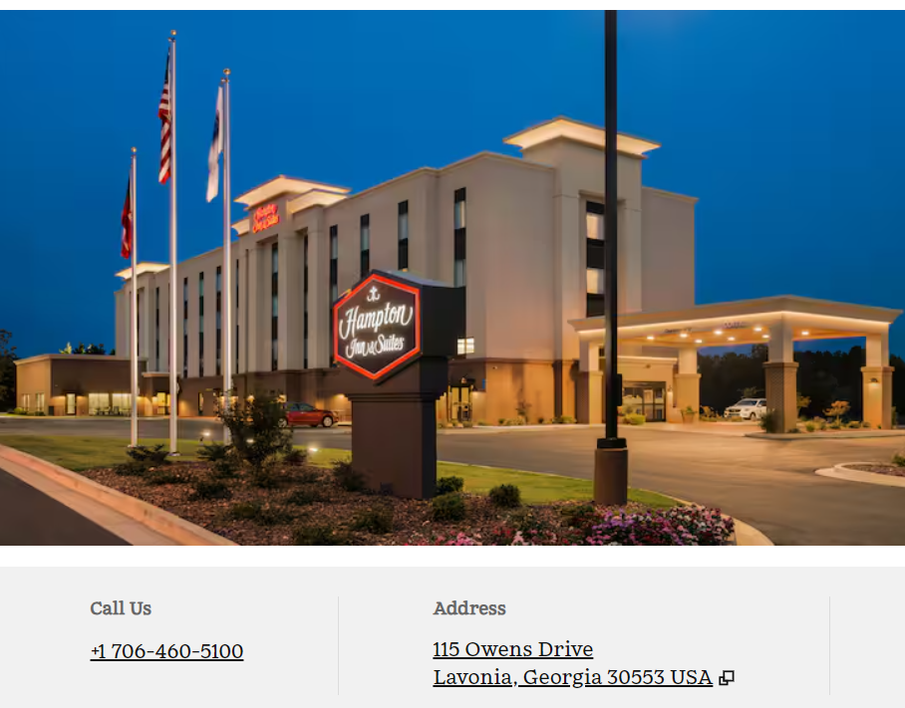

Click here for link to Hampton Inn in Lavonia, GA website.
Cornelia, GA
Places in Cornelia, GA listed below. Distance from college within approximately 15 to 19 miles
Examples of places to eat in Cornelia, Georgia:
Fast food: Chick-fil-a, Captain D’s, Waffle House, Food Factory
Local: Fenders Diner, Stew N Que, El Patron, Bigg Daddy’s Restaurant
Chain: Marco’s Pizza, Longhorns Steakhouse

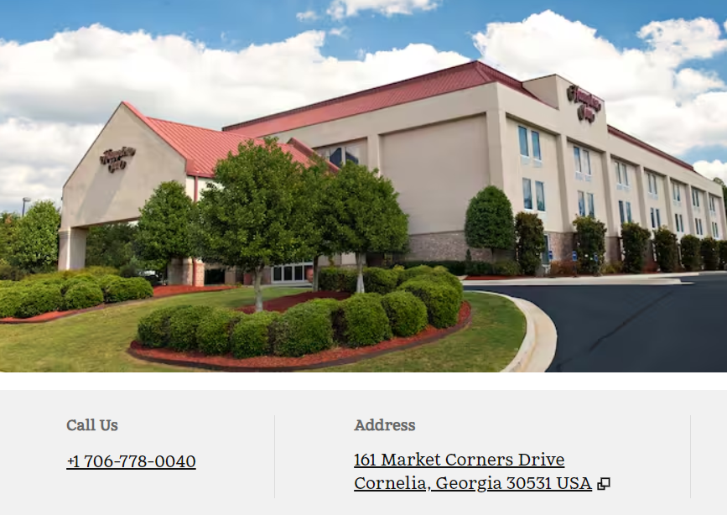
Click here for link to Hampton Inn in Cornelia, GA website.

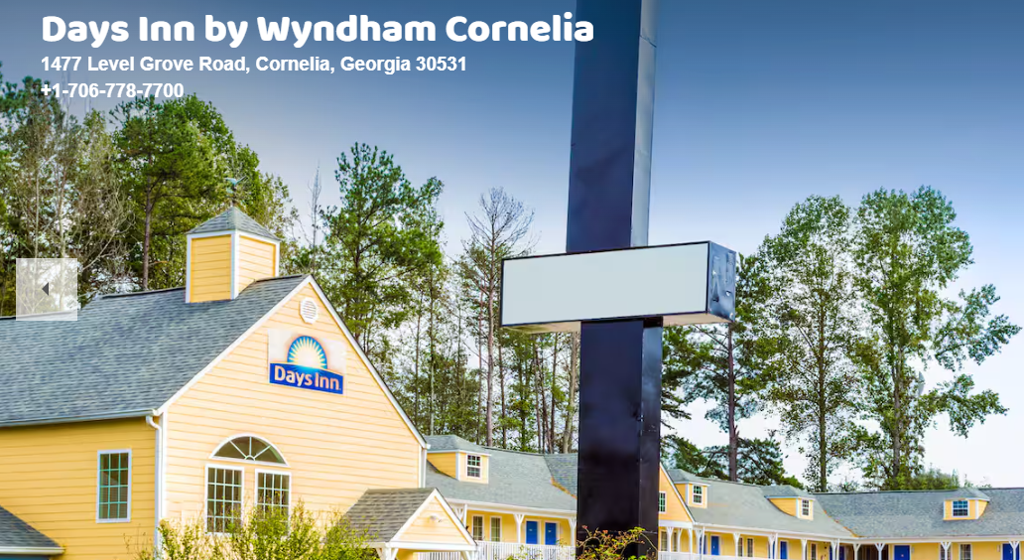
Click here for link to Days Inn by Wyndham, GA website.

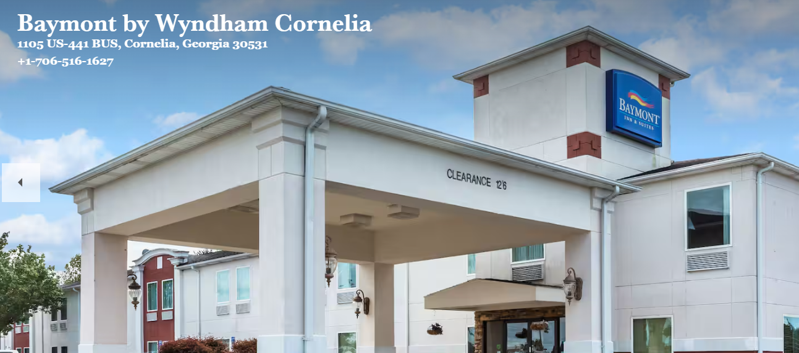

Click here for link to Baymont by Wyndham in Cornelia, GA website.

Airbnb Toccoa GA - Click here.
Airbnb Options Near Toccoa Falls Click here.
Example:
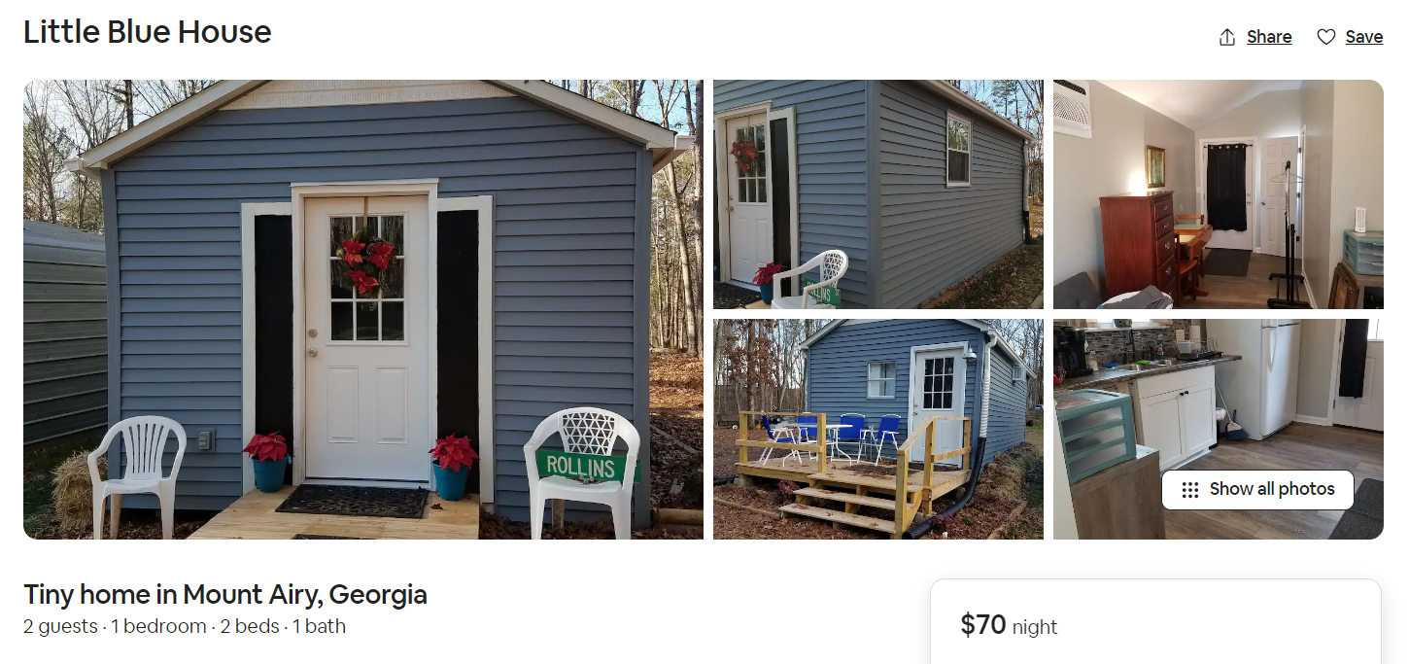
Click here.
Campground/ RV
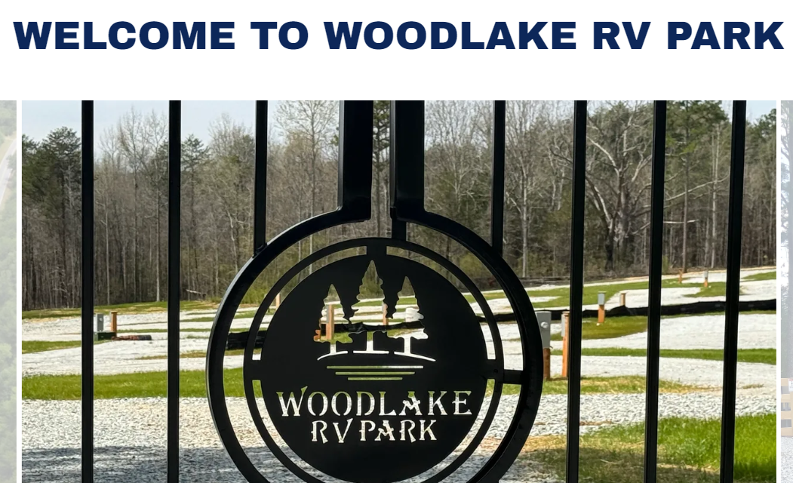 Click here.

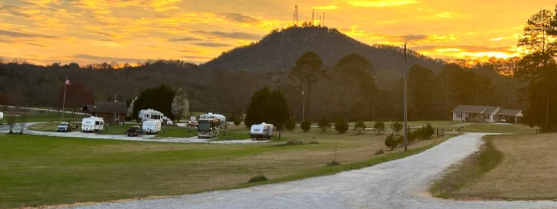
Click here Curahee RV Park

